Log into Portal
This User Guide outlines the steps required to log in to the CMS Portal, and is divided into two parts:
Topic | Page
Logging In | 2
Activating your CMS Portal account | 4

Logging In
Note:
If you are unable to log in to your CMS Portal account after following this User Guide, or one hasn’t been set up for you, please contact the CMS Portal Administrator for your organisation’s account.

Step | Action |  | Result
 | On the CMS Portal home screen, click: Log-In |  | The Log-In screen displays:  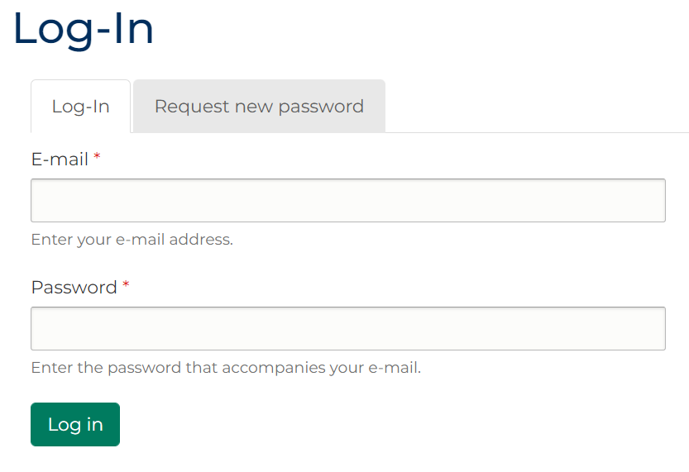
Note:
Fields marked with a red asterisk * are mandatory.
Hint:
To request a new password which is sent to the e-mail address linked to your CMS Portal account, click: Request new password
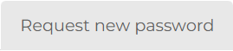
 | Type your E-mail and Password in the relevant fields, then click: Log in |  | 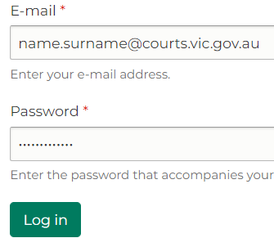
Note:
You may be required to verify your account via Two-Factor Authentication (2FA).
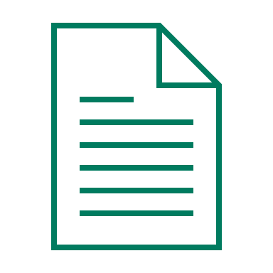 |  | Please see:  For further information on the 2FA process, please see the second section of this User Guide.
 | The CMS Portal home screen displays |  | 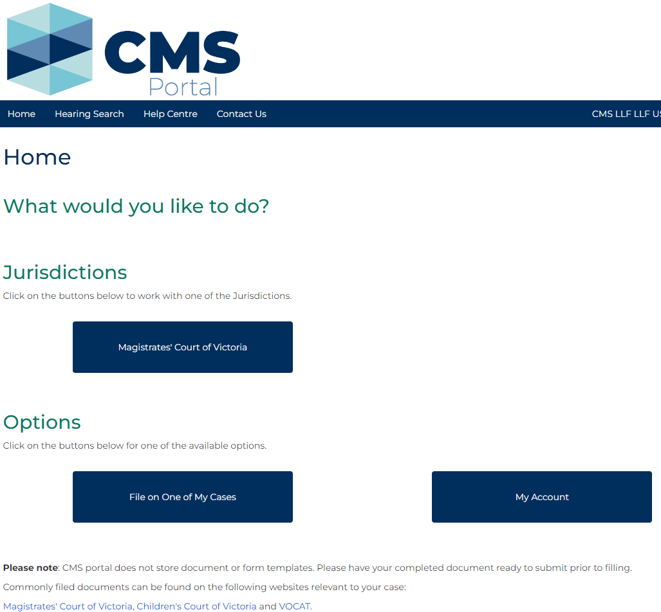
Note:
Click the relevant button to complete the desired action.
Please see:
For further information on using the CMS Portal features on the Home page, please see the relevant User Guide.

Activating your CMS Portal account
Note:
CMS Portal user accounts are created by the CMS Portal Administrator for your organisation’s account.

Step | Action |  |  | Result
 | Click the account activation link in the Welcome to the CMS Portal email sent to the email address linked to your CMS Portal Account:  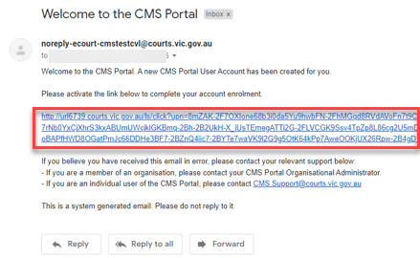 |  |  | 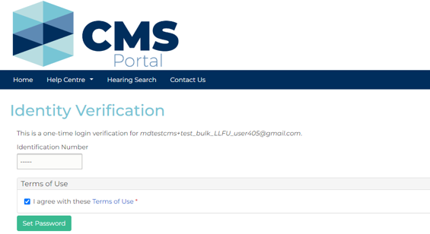  The Identity Verification screen displays:
Note:
You may not be prompted to enter an Identity Verification number and accept terms and conditions.
 | Review the Terms of Use then click: Set Password |  |  | The My Account screen displays: 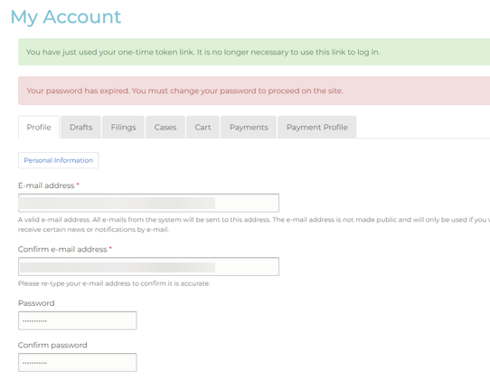
 | Type a new password and click: Save |  |  | A confirmation message displays:  The Register popup displays:  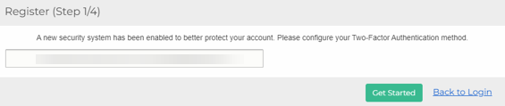
 | Enter email address associated with your CMS Portal account and click: Get Started |  |  | The Verify Email popup displays:  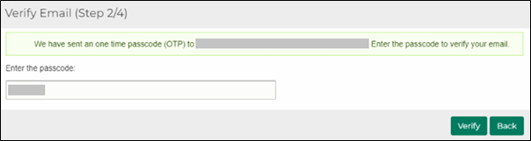
 | Enter the one-time passcode that was sent to your email and click: Verify |  |  | The Select Authentication method popup displays:  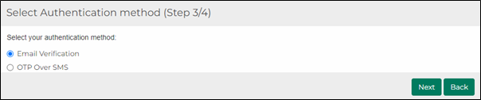
 | Select either:  - Email Verification – go to step 7, or  - OTP Over SMS – go to step 9  And click: Next |  |  | The Verify your identity screen displays:  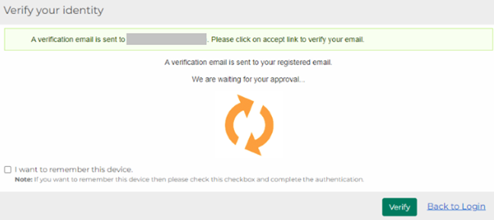
 | Email Verification  A second email will be sent to the email address associated with your CMS Portal account. Click: Accept Transaction |  |  | The Transaction Successful popup displays:  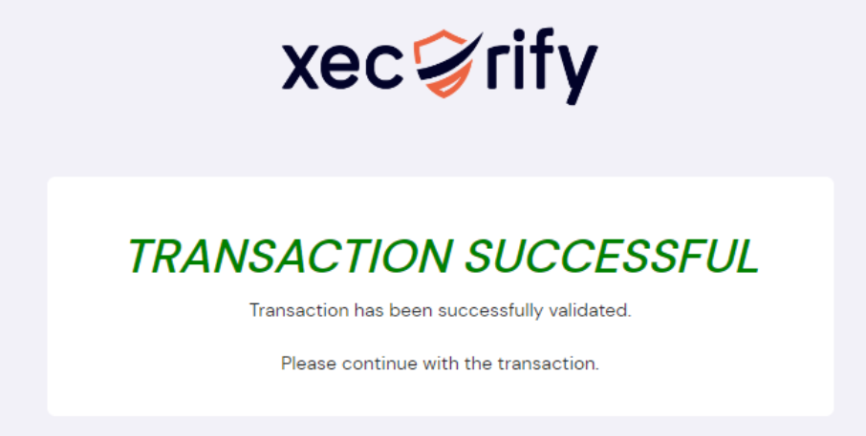
 | Click: Verify in the CMS Portal |  |  | A confirmation message displays:
Note:
To reduce how often you need to verify your identity to access the CMS Portal – select: I want to remember this device, then click: Verify
If you don’t use another device/browser, you will not be sent a verification email for 14 days.
If you change the email address linked to your CMS Portal account, you will need to contact the CMS Support Team to reset your 2FA.
 | OTP Over SMS |  |  | 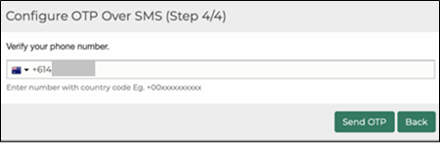
 | Enter the mobile number you wish to register into the Verify your phone number field and click: Send OTP |  |  | The Configure OTP Over SMS popup displays:  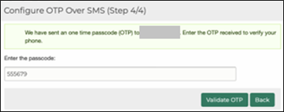
 | Enter the passcode that was sent to the mobile and click: Validate OTP |  |  | A confirmation message displays:
Note:
To reduce how often you need to verify your identity to access the CMS Portal – select: I want to remember this device, then click: Verify
If you don’t use another device/browser, you will not be sent a verification email for 14 days.
If you change your mobile number, you will need to contact the CMS Support Team to reset your 2FA.

