Request access to case
This User Guide outlines the process required to request access to a case, which your account does not have access to, in the CMS Portal.
Step | Action | Result
 | Log into the CMS Portal | The CMS Portal screen displays:  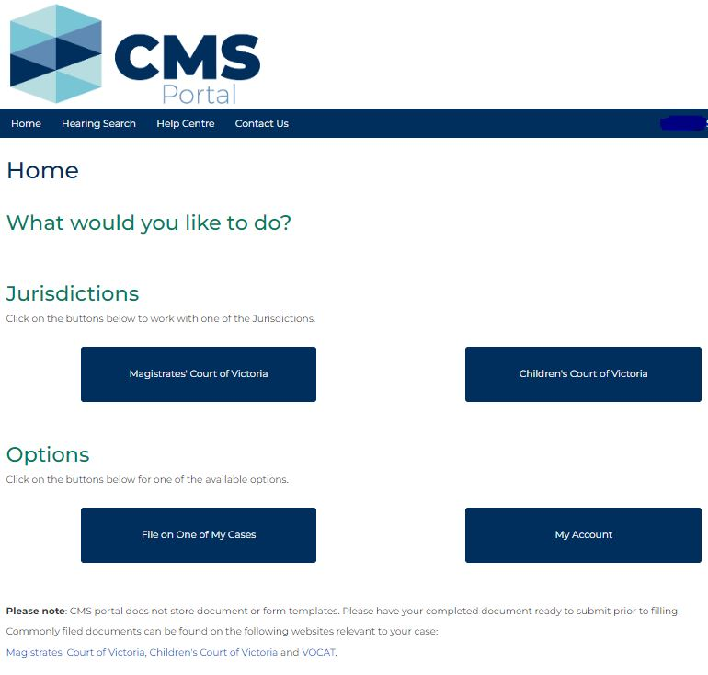
 | Select the relevant jurisdiction:  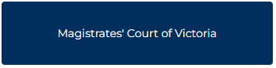 | Select the relevant Case Type:  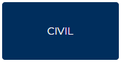
 | Click: REQUEST CASE ACCESS  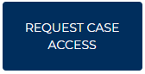 | The Case Access Search screen displays:  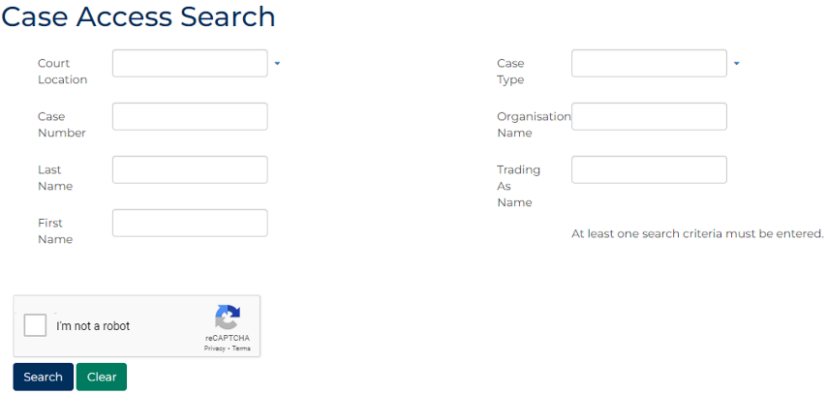

Step | Action | Result
Enter at least one search criteria into the displayed fields:
PANEL: Case Access Search
In this field … | Provide this information …
Court Location | Select the relevant Court Location
Case Number | Type the relevant Case Number
Last Name | Type the Last Name of the relevant party.
First Name | Type the First Name of the relevant party.
Case Type | Select the relevant Case Type
Organisation Name | Type the Organisation Name of the relevant party.
Trading as Name | Type the Trading Name of the relevant party.

 | Select: I’m not a robot  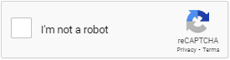  Select all images matching the request. Example:  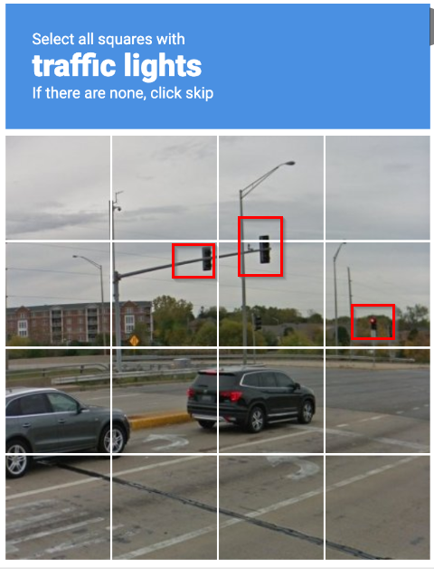  Click: Search  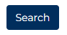 | Results matching the search criteria display:  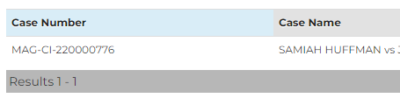
Hint:
If the relevant case does not appear in the search results, return to step 4 and refine your search criteria.

Step | Action |  | Result
 | In the Action column for the relevant case, select: Request Access  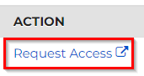 |  | The Request Case Access screen displays in a new tab:  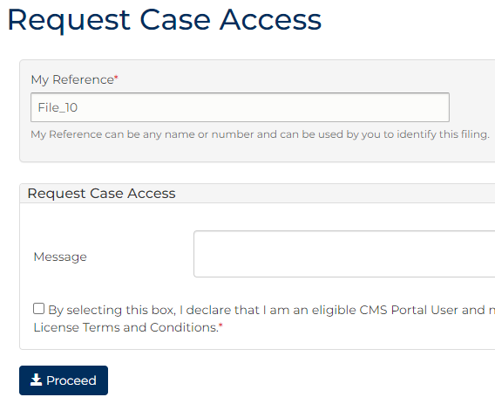
Complete the required panels and fields:
Fields marked with a red asterisk * are mandatory.
SCREEN: Request Case Access
In this field … | Provide this information …
My Reference | Displays a system generated reference. Replace with unique reference to personally identify filing.
Message | Type relevant information to support the case access request.

 | If appropriate, select the box to acknowledge you are an eligible user who should be able to access the case.
Important:
Only select this box if you should have access to this case, in accordance with the Case Management System End User License Terms and Conditions.
View the terms of use in the Quick Links menu on the CMS Portal home page.

Step | Action |  | Result
 | Click: Proceed |  | The Confirmation of Filing screen displays a confirmation message:  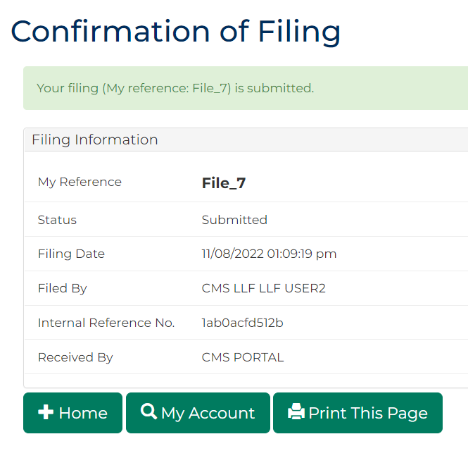
Select the relevant button to continue using the CMS Portal:
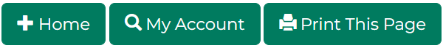
Important:
The email associated with your CMS Portal account is sent confirmation of case access:
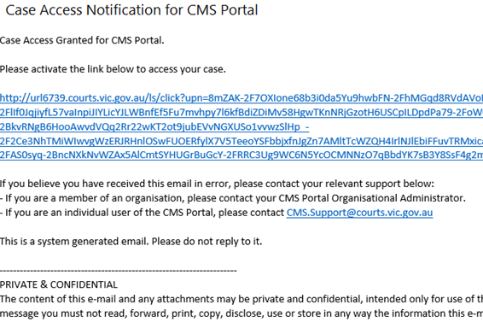

Step | Action | Result
 | In the Case Access Notification email, click the link to activate case access. | A new tab displays a confirmation message in the CMS Portal  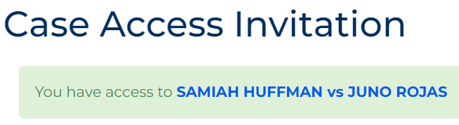
 |  | 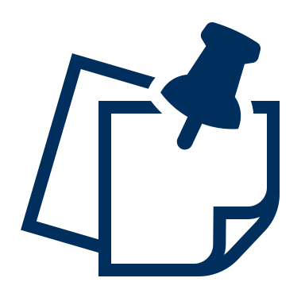 | Note:  The case is now accessible in the Cases tab on the My Account screen.
 |  | 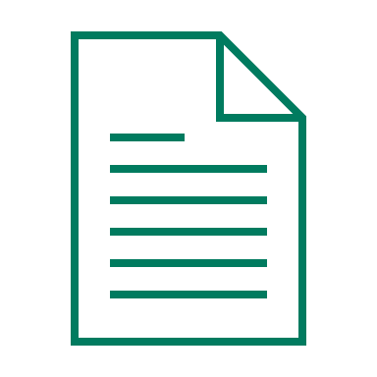 | Please see:  For information regarding the process to access a case in your CMS Portal account, please see User Guide: Cases

