File subcase on existing case
Portal User Guide

Purpose
User Guide shows how to: File subcase on existing case in CMS Portal
Resource:
To view full list of lodgements and subcase types, visit CMS Help Centre > Forms and Fees > Forms (CMS Portal Forms) > Filing Forms

- Log in to Portal.
Home screen displays:
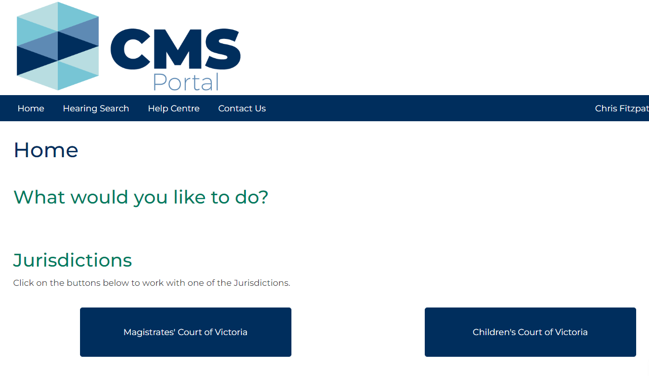

- Click: File on One of My Cases
Search Case screen displays:
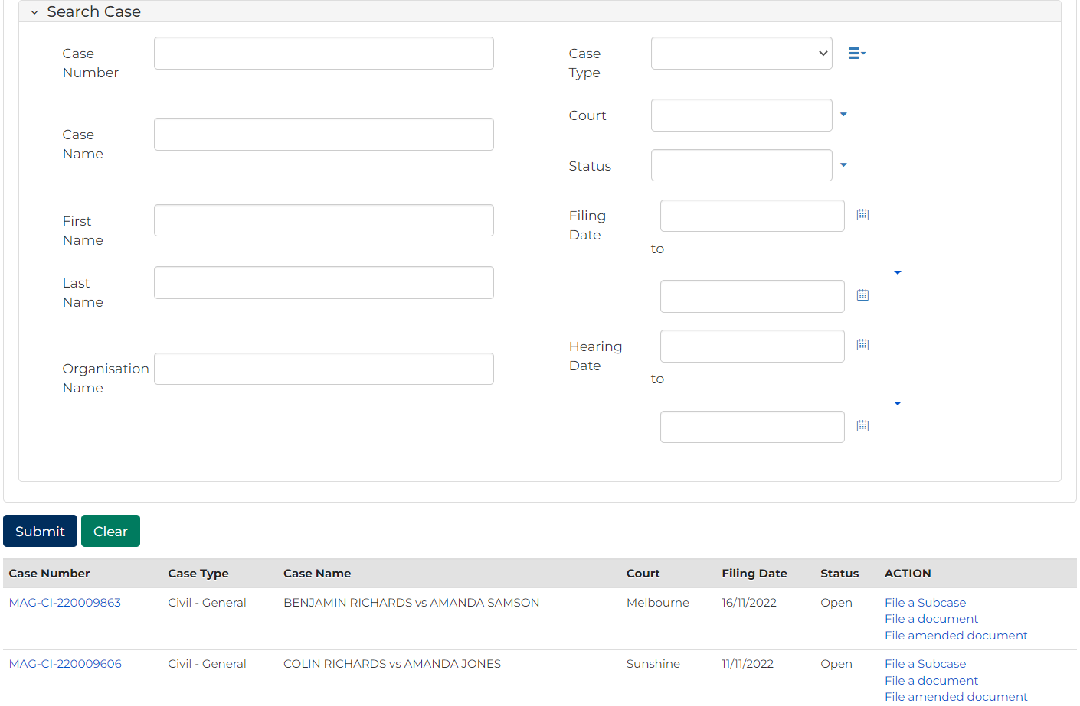
Note:
List of cases that have permitted access displays at bottom of screen. If relevant case is visible in this list, click Case Number to access or link in Actions column to file on case
This page enables to search by numerous filters
If viewing is denied, requesting access to case is required

Resource:
See User Guide: Request access to a case

- Complete required panels and fields
Panel: Search Case
Field: | Action:
Case Number | Type full or partial Case Number.
Case Name | Type full or partial Case Name.
First Name | Type First Name of a party in case.
Last Name | Type Last Name of a party in case.
Organisation Name | Type Organisation Name.
Case Type | Select relevant option.
Court | Select relevant option.
Status | Select relevant option.
Filing Date | Select date (or range of dates) of filing.
Hearing Date | Select date (or range of dates) of hearing.

- Click: Submit
Results panel displays cases matching search criteria:
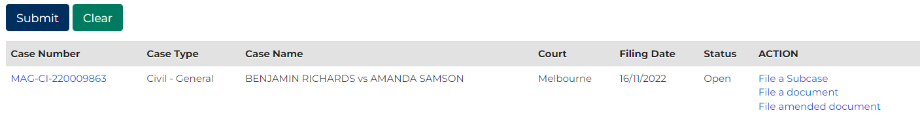
Notes:
If relevant case does not display in list of results, adjust search criteria and click: Submit
To reset all fields, click: Clear
- In Action column for relevant case, click: File a Subcase link.
Add Subcase screen displays:
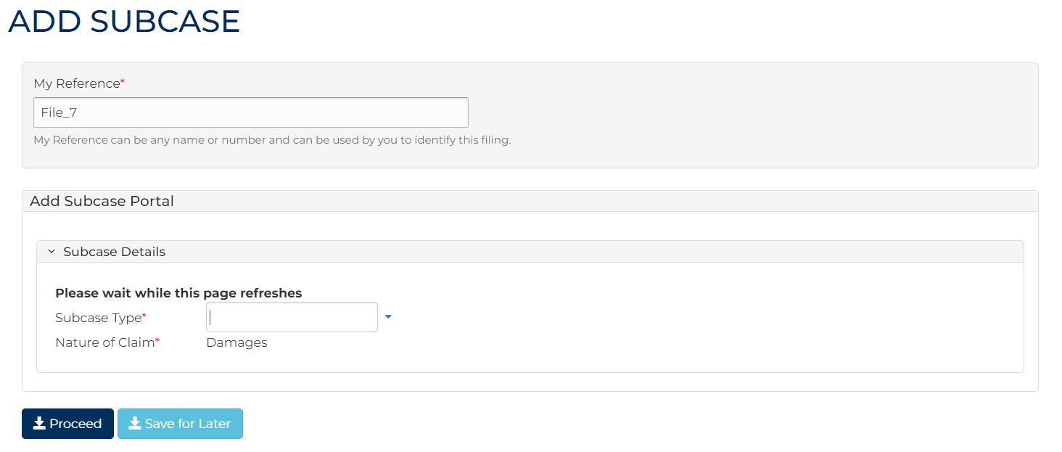
Note:
Panels and fields will vary depending on subcase type selected.

- Complete required panels and fields.
Panel: My Reference
Field: | Action:
My Reference | Type reference name or number to identify filing.

Panel: Subcase Details
Field: | Action:
Subcase Type | Type or select subcase name from menu.  Note:  - Subcase type is based on lodgement being filed  To view full list of lodgements and subcase types, visit CMS Help Centre > Forms and Fees > Forms (CMS Portal Forms) > Filing Forms
Nature of Claim | The nature of claim displays. This cannot be changed.

Note:
Common fields are listed in tables below. These may not appear in all subcase types.

Panel: Subcase Initiating Document
Field: | Action:
Code/Name | The relevant form will display.
Upload Document | Click: Choose File and add required PDF document to case.  Note:  All document uploads must be PDF

Additional Panels
Field: | Action:
Filed By | Select party.
Representation | Select filing party’s legal representation if applicable.  To add representation, click: Add Representation
Filed Against | Select party.  To add representation, click: Add Filed Against then type the details of the new party in the fields provided.
Required Documents (1) | Document will be listed if required.  Click: Choose File and add required PDF document to case.  Note:  All document uploads must be PDF.
Additional Documents (1) | Select additional filed documents as required.
Fee Waiver Panel | Change to Yes if applying for a fee waiver.

- Click: Proceed
My Account screen displays:
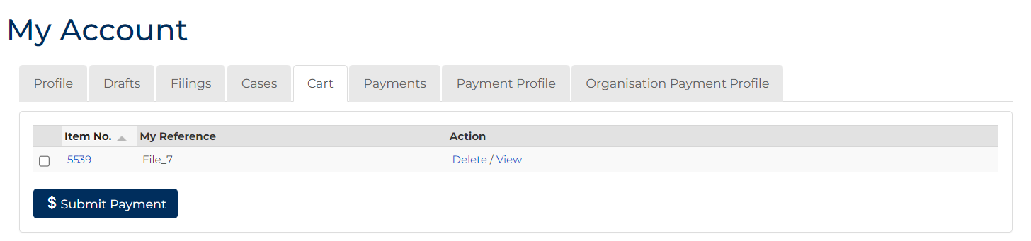
- Select item requiring payment. Click: Submit Payment
Process Payment screen displays:
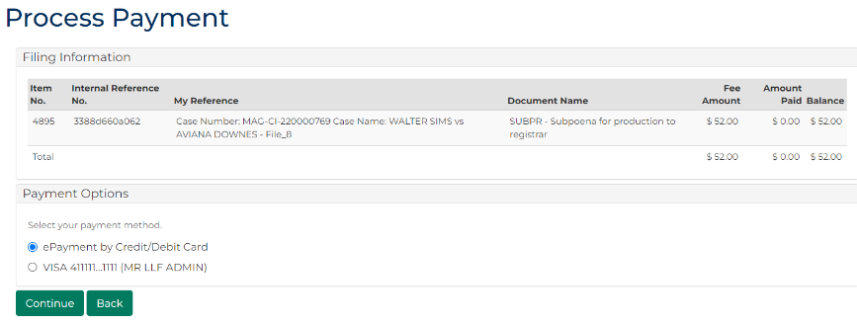

- In Payment Options panel, select payment method, click: Continue
- If ePayment by Credit/Card is selected, a pop-up box displays. Type your payment details.
- Click: Make Payment
Confirmation of Filing screen displays:
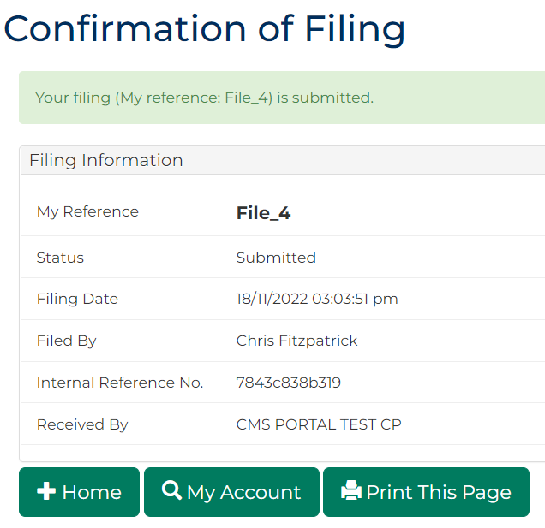
Notes:
Acknowledgment for filing email is sent to Portal user when document is filed
An additional email is sent once document is reviewed by registry staff
- Click: My Account
My Account screen displays indicating pending review, accepted or rejected:
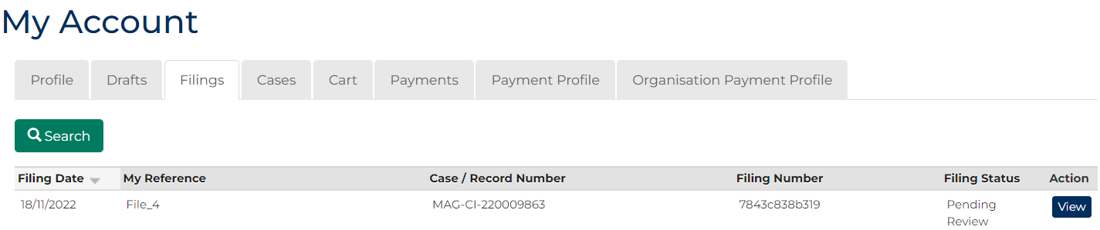
- To see record of filing, in the Action column, click: View
Case Summary screen displays:
