File new case - Interstate registration
Step | Action |  |  | Result
 | Log into the CMS Portal |  |  | The CMS Portal Home screen displays:  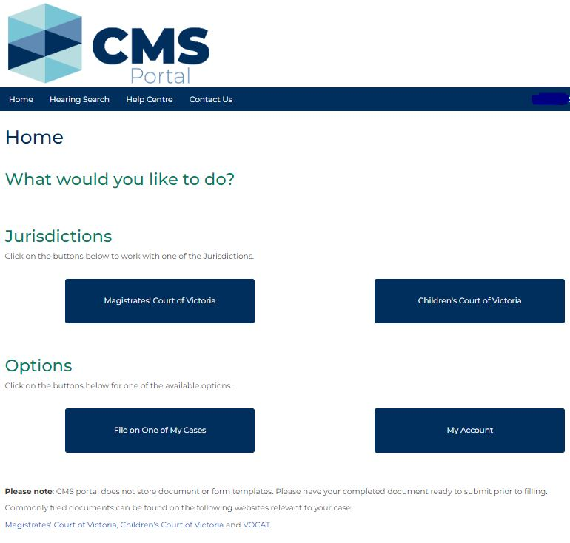
 | Click: Magistrates’ Court of Victoria |  |  | The Select a Case Type screen displays:  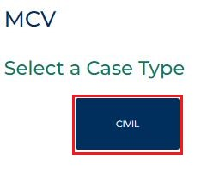
 | Click: CIVIL  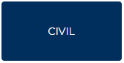 |  |  | The Commence a new case screen displays:  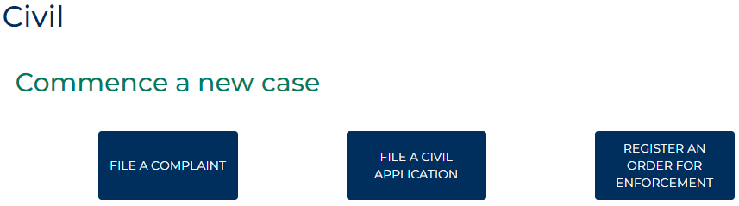
 | Click: Register an order for enforcement  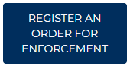 |  |  | The Register/Enforce Order screen displays:  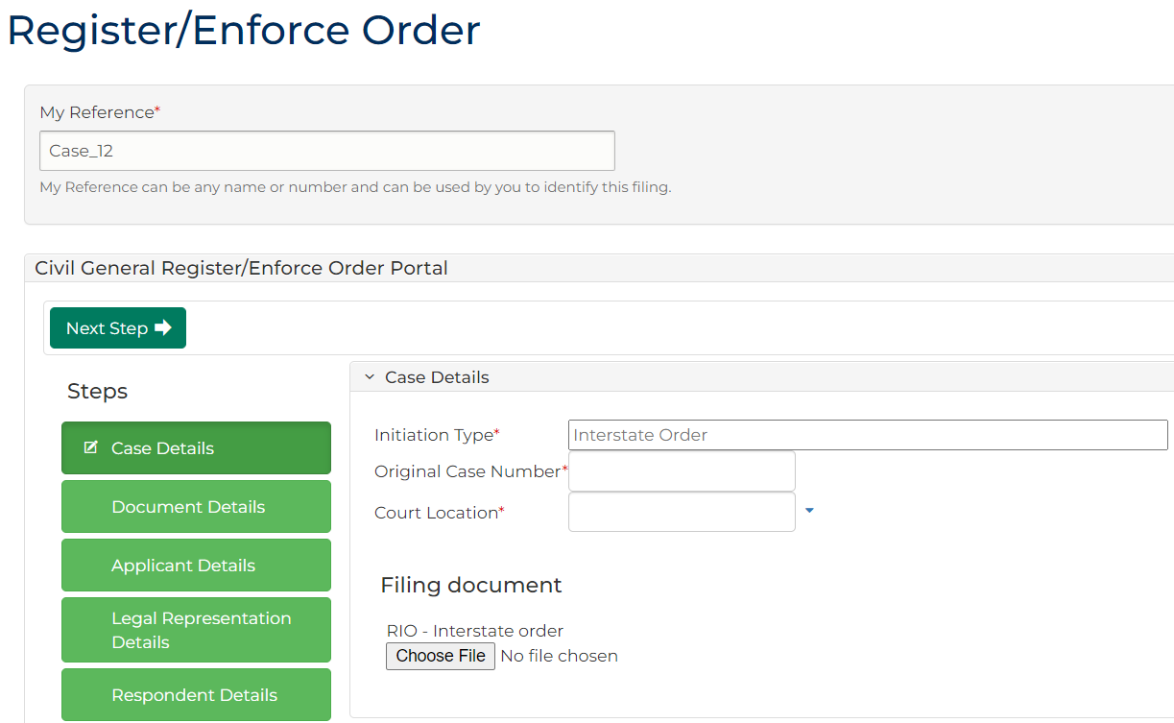
Complete the required panels and fields:
Fields marked with a red asterisk * are mandatory.
PANEL: My Reference
In this field … | Provide this information …
My Reference | Any name or number used by you to identify the filing.

Complete the required panels and fields:
PANEL: Case Details
Initiation Type | Displays Interstate Order, do not change.
Original Case Number | Type the original case number.
Court Location | Select the court to which you are filing the interstate order.
Filing document | Click and upload the relevant PDF.

 | Click: Next Step |  |  | The Document Details panel displays:  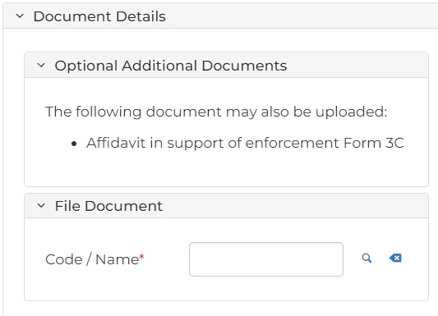  Start typing the name of the Code/Name and select relevant document from the results displayed. Click Choose File and upload the relevant PDF.
 | Click: Next Step |  |  | The Applicant Details (1) panel displays:  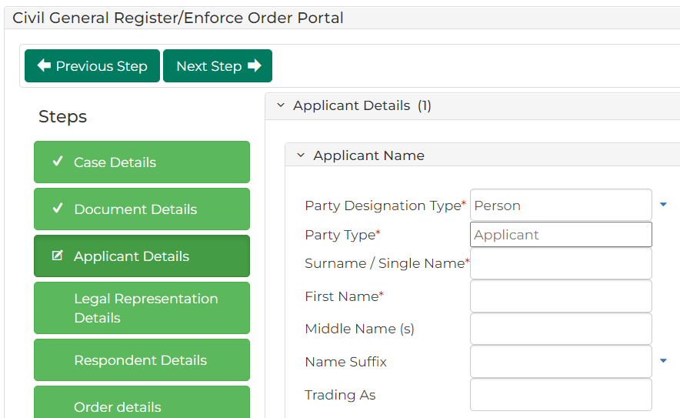
Complete the required panels and fields:
PANEL: Applicant Name
In this field … | Provide this information …
Party Designation Type | Select the type making the claim.
Note:
Fields change depending on the selected Party Designation Type.
Party Type | Displays: Applicant.
Surname/Single Name | Type the family name of the applicant.
First Name | Type the given name of the applicant.
Middle Name(s) | Type any additional names of the applicant.
Name Suffix | Select if required.
Trading As | Type the trading name recorded for the applicant.
PANEL: Applicant Address
Address Type |  | Select the address type.
Physical Address |  | Start typing the address into the search box and select the correct option from the results.
Hint:
To add additional addresses, click: Address Details
PANELS: Contact Details & Financial Details
Type all available contact and financial information.
PANEL: Applicant Identification
Australian Business Number (ABN) |  | Type the Australian Business Number (ABN) for the plaintiff, if relevant.
Continued …
Continued …
PANEL: Representation Capacity or Litigation Guardian
In this field … | Provide this information …
Are you acting in a Representative Capacity? | Select either: Yes or No
Do you have a Litigation Guardian? | Select either: Yes or No

 | Click: Next Step |  |  | The Applicant's Legal Representation Details panel displays:  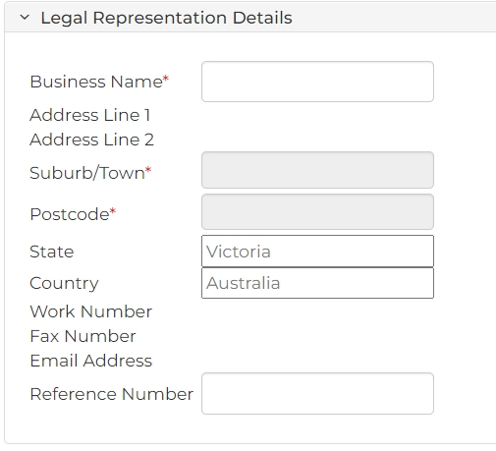
Complete the required panels and fields:
PANEL: Representation Name Details
In this field … | Provide this information …
Business Name | Start typing the name or code of your legal firm and select the correct option from results.
Note:
The address fields populate based on the firm you select.
Reference Number | Type the legal firm’s reference number if provided.

 | Click: Next Step |  |  | The Respondent Details panel displays:  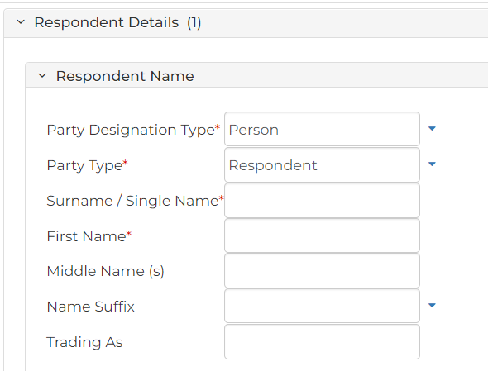
Complete the required panels and fields:
PANEL: Respondent Name
In this field … |  | Provide this information …
Party Designation Type |  | Select Party Designation Type
Note:
Fields have different values depending on the selected Party Designation Type.
ACN may also appear, depending on Party Designation Type selected.
Party Type |  | Displays: Respondent.
Surname/Single Name |  | Type the family name of the respondent.
First Name |  | Type the given name of the respondent.
Middle Name(s) |  | Type any additional names of the respondent.
Name Suffix |  | Select if required.
Trading As |  | Type the trading name recorded for the respondent.
PANEL: Respondent Address
Address Type |  | Select the address type
Physical Address |  | Start typing the address into the search box and select the correct option from the results.
Hint:
To add additional addresses, click: Address Details
PANEL: Defendant Identification Details
Australian Business Number (ABN) |  | Provide the Australian Business Number (ABN) for the defendant, if relevant.

 | Click: Next Step |  |  | The Order details panel displays:  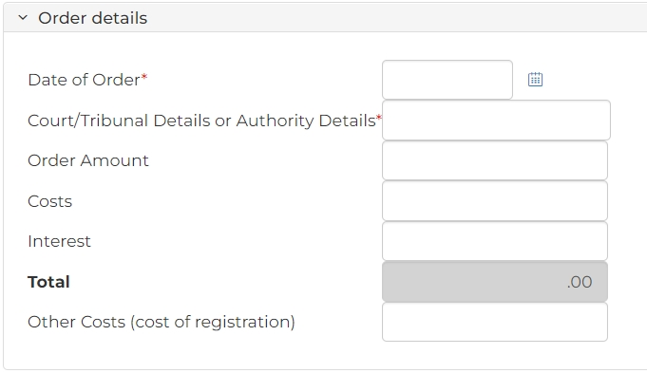
Complete the required panels and fields:
PANEL: Order Details
In this field … | Provide this information …
Date of Order | Click the Calendar icon to record the date the Order was made.
Court/Tribunal Details or Authority Details | Start typing the interstate destination into the search box and select the correct court/tribunal details from the results.
Order Amount | Type the amount of the Order.
Costs | Type the costs awarded in the Order.
Interest | Type the amount of interest awarded in the Order
Total | Portal automatically calculates the total.
Other Costs (cost of registration) | Type the amount of costs requested to be ordered for the registration.

 | Click: Next Step |  |  | The Fee Waiver panel displays with No as a default. Change to Yes if needed.  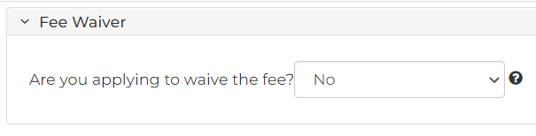
 | Click: Proceed |  |  | The My Account screen displays:  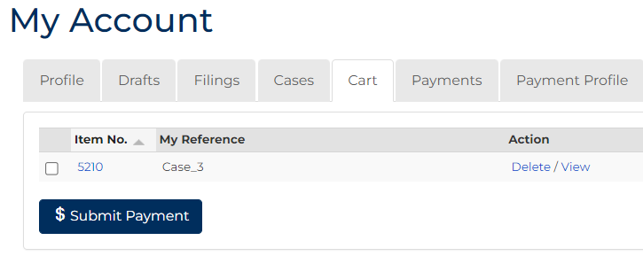
 | Select the item number requiring payment.
 | Click: Submit Payment |  |  | The Process Payment screen displays:  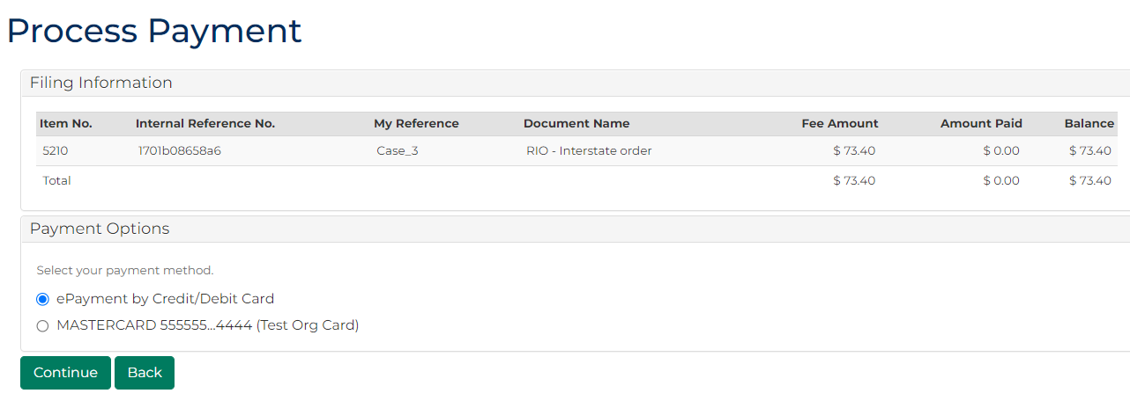
 | From the Payment Options panel, select a payment method, then click: Continue |  |  |  | Please See:  Payment options can be added and removed from the My Account screen. For more information, please see User Guide: My account features
Note:
If ePayment by Credit/Debit card is selected, a popup displays.
Enter your payment details, then click: Make Payment
 | The Interstate Registration is filed. |  |  | The Confirmation of Filing screen displays:  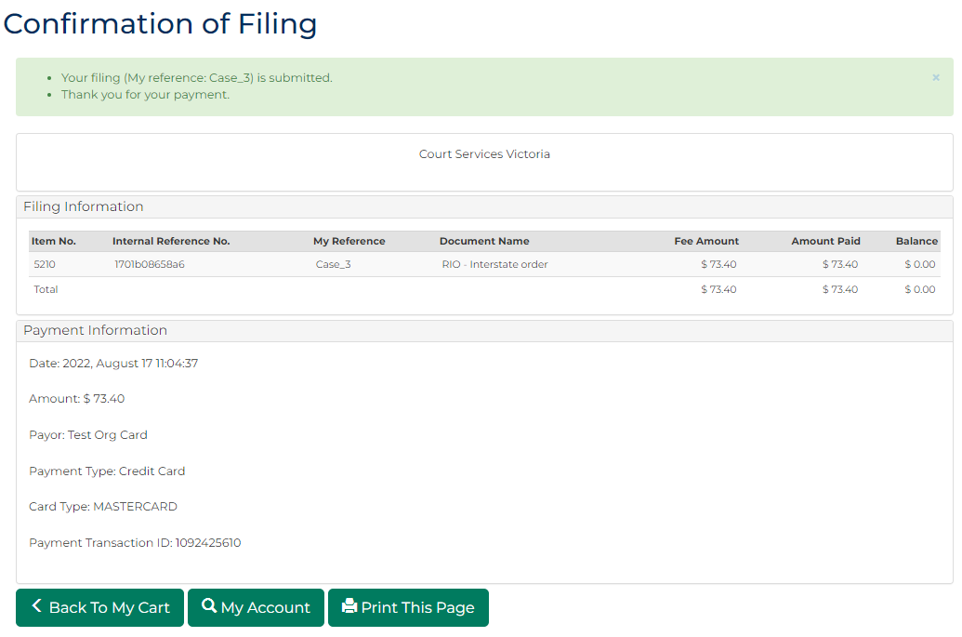
 | Click: My Account |  |  | The My Account screen displays:  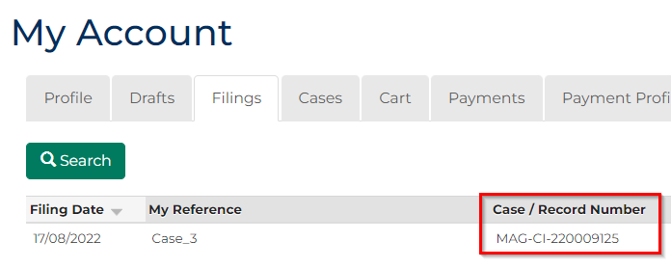
Note:
The Case/Record Number for the courts system is generated for future reference and an acknowledgment for filing email is sent to the nominated address within your user profile settings.
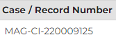
 | OPTIONAL:  Under the Action panel, click: View  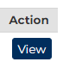 |  |  | The Case Summary screen displays:  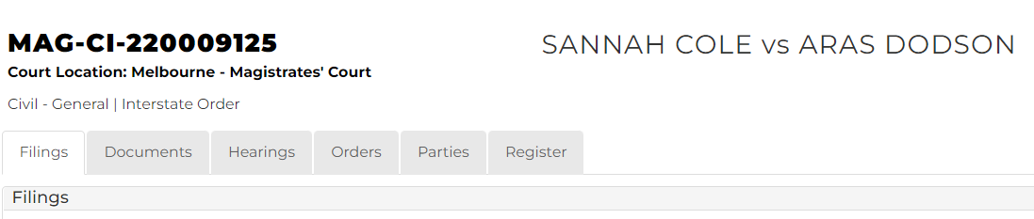
Note:
Once the filing is accepted, you can access a copy of the order from the Documents tab of the Case Summary screen.
A Notice of registration to Interstate/NZ court is available to download in the Generated Documents field.

