File new case - civil complaints initiation process
Note:
At any stage before a complaint is submitted you may click: Save for Later
to save a draft of the complaint.
The draft complaint can be retrieved from the Drafts tab on the My Account screen of the CMS Portal.
Please See:
For more information regarding managing your account, please see User Guide: My Account Features

Step | Action |  |  | Result
1 | Log into the CMS Portal |  |  | The CMS Portal screen displays:  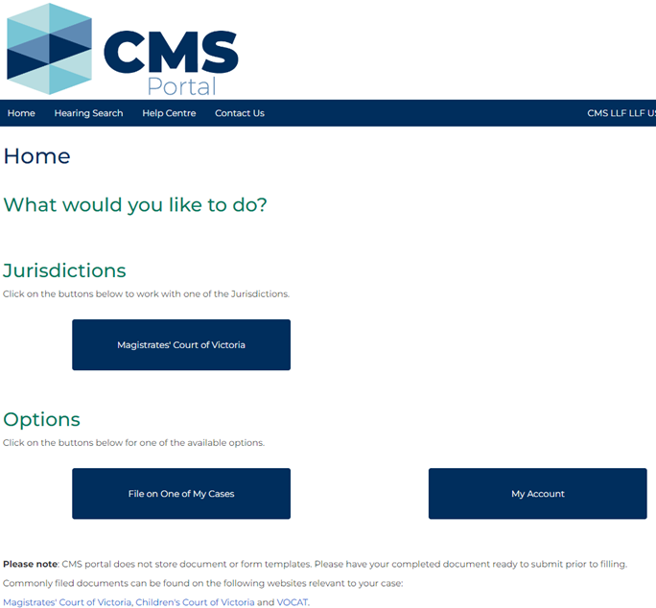
2 | In the Jurisdictions section, click: Magistrates’ Court of Victoria  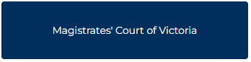 |  |  | The Select a Case Type screen displays:  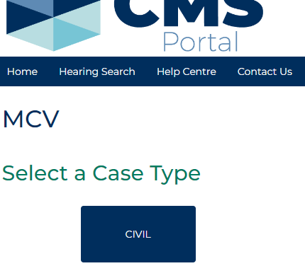
3 | Click: CIVIL  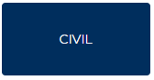 |  |  | The Civil screen displays:  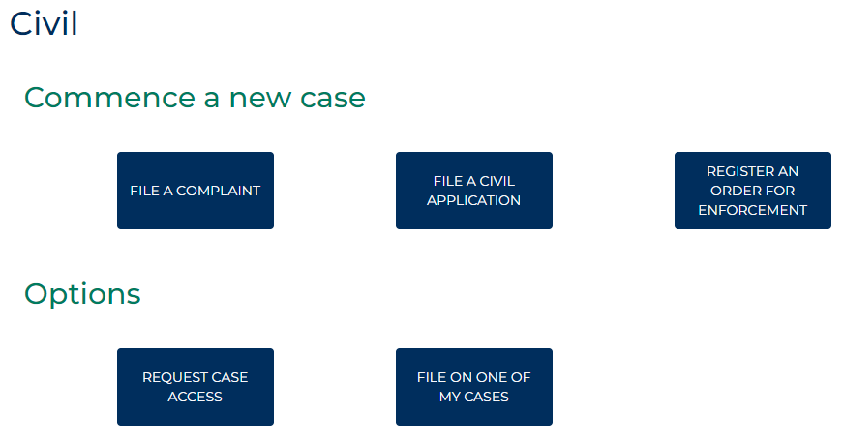
4 | Click: File A Complaint  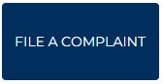 |  |  | The Civil Complaints screen displays:  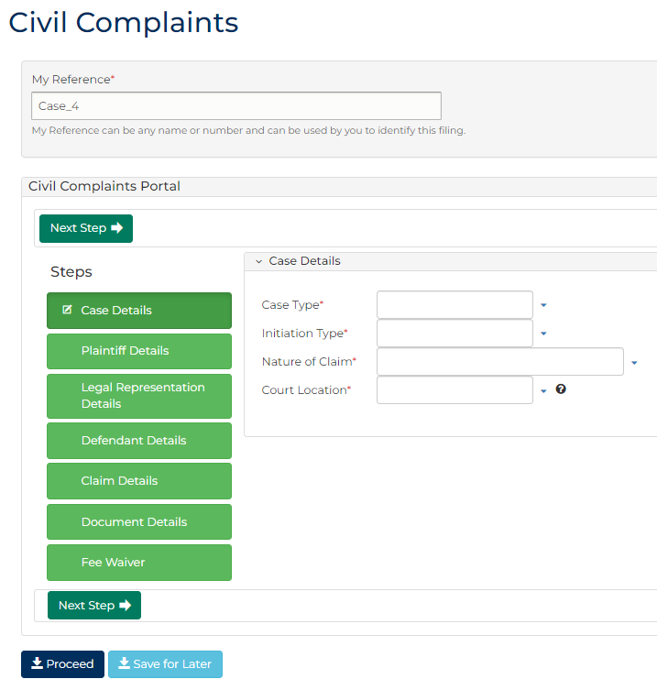
5 | Complete the required panels and fields:  Fields marked with a red asterisk * are mandatory.  PANEL: My Reference  In this panel … Provide this information …  My Reference Reference field unique to the filing. Displays a system generated reference. Can be replaced by any reference useful for plaintiff or legal representation to locate and identify the filing.  PANEL: Case Details  Case Type Select the case type.  Initiation Type Select the Initiation type.  Nature of Claim Select the nature of claim.  Court Location Type the name of the venue for the matter.
6 | Click: Next Step |  |  | The Plaintiff Details (1) screen displays:  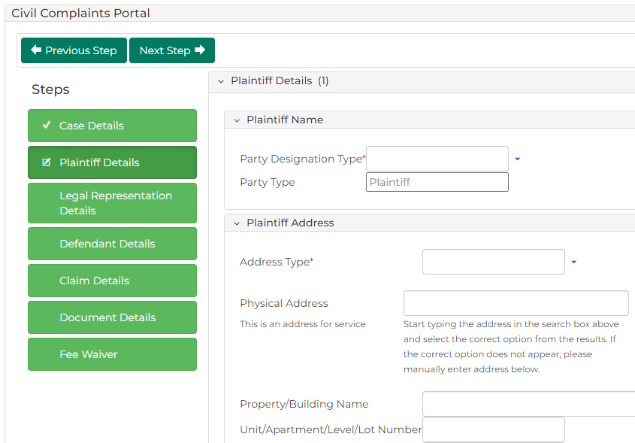
Hint:
When moving between sections, you can also select the green heading tiles (e.g. Case Details, Defendant Details) on the left of the screen to proceed to the desired section.
7 | Complete the required panels and fields:  PANEL: Plaintiff Details  In this field … Provide this information …  Party Designation Type Select the type of plaintiff making the claim.  Important:  When designated party is business, select Organisation as designation type.  'Agency' and 'Company' are currently invalid.  Note:  The fields that display will change depending on the Party Designation Type selected.  Party Type Displays: Plaintiff  Surname/Single Name Type the surname of the plaintiff.  First Name Type the first name of the plaintiff.  Middle Name(s) Type any middle names of the plaintiff.  Name Suffix Select if required, can be left blank.  Trading As If relevant, type the trading name of the plaintiff.  PANEL: Plaintiff Address  Address Type Select the address type for the plaintiff’s address.  Physical Address Start typing the address and select the relevant option from the results.  Note:  If the desired address is not displayed with the search feature, you can type each component of the address in the relevant fields.  Continued …
7 | Continued …  ADDITIONAL PANELS  In this panel … Provide this information …  Plaintiff Contact Details Type the contact details for the plaintiff into the relevant fields. You do not need to complete all fields.  Plaintiff Identification Details Type the Australian Business Number (ABN) of the plaintiff, if applicable.  Plaintiff Financial Details Type the financial details for the plaintiff, if applicable.  Plaintiff Representation Capacity or Litigation Guardian Dropdown menus display No. Change if required.
8 | Click: Next Step |  |  | The Legal Representation Details screen displays:  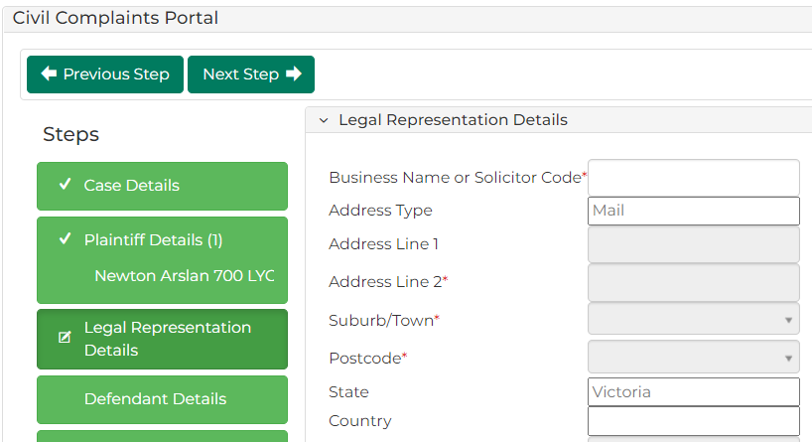
Complete the required panels and fields:
PANEL: Legal Representation Details
In this field … | Provide this information …
Business Name or Solicitor Code | Start typing the address and select the relevant option from the results. This will then populate the relevant fields.

9 | Click: Next Step |  |  | The Defendant Details (1) screen displays:  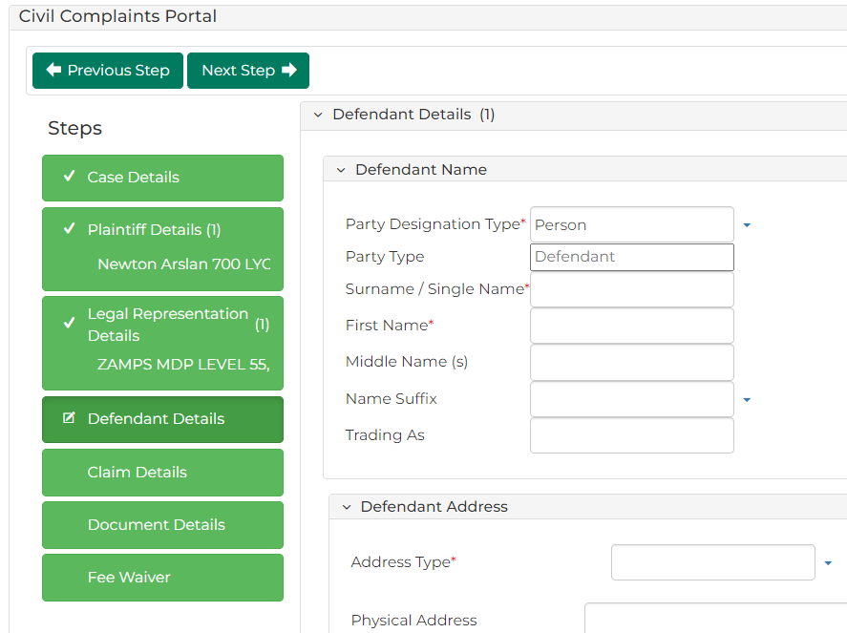
10 | Complete the required panels and fields:  PANEL: Defendant Name  In this field … Provide this information …  Party Designation Type Select the party type.  Important:  When designated party is business, select Organisation as designation type.  'Agency' and 'Company' are currently invalid.  Note:  Fields have different values depending on the Party Designation Type selected.  Party Type Displays Defendant  Surname/Single Name Type the surname of the defendant.  First Name Type the first name of the defendant.  Middle Name(s) Type any middle names of the defendant.  Name Suffix Select if required, can be left blank.  Trading As If relevant, type trading name of the defendant.  Continued …
10 | Continued …  PANEL: Defendant Address  Address Type Select the address type for the defendant’s address  Physical Address Start typing the address and select the relevant option from the results.  Note:  If the desired address is not displayed with the search feature, you can type each component of the address in the relevant fields.  PANEL: Defendant Identification Details  Australian Business Number (ABN) Type the Australian Business Number (ABN) of the defendant, if applicable.  Australian Company Number (ACN) Type the Australian Company Name (ACN) of the defendant, if applicable.  Note:  Australian Company Number (ACN) only appears if Organisation is selected in Party Type
11 | Click: Next Step |  |  | The Claim Details screen displays:  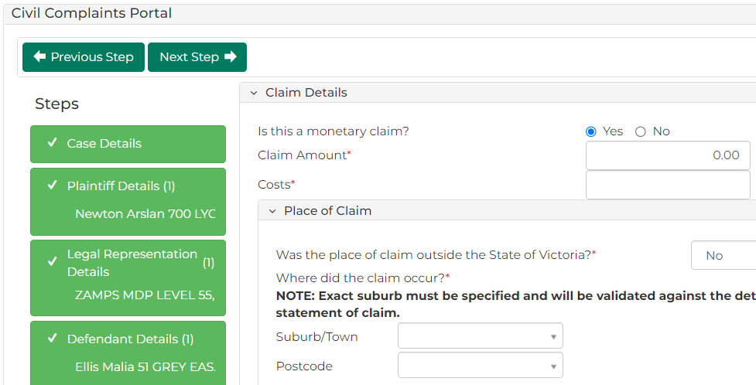
12 | Complete the required panels and fields:  PANEL: Claim Details  In this field … Provide this information …  Is this a monetary claim? Select Yes or No  Claim Amount Type the claim amount.  Costs Type the costs amount (if no costs are claimed, type 0)  Was the place of claim outside the state of Victoria? Displays No, only change if required.  Suburb/Town Type the suburb for the claim and select from the results.  Hint:  You can leave the Suburb/Town field blank and type the Postcode instead. Select the relevant suburb from the results provided.  Postcode Automatically displays if suburb has been selected.  Claim details Type the details for the Statement of Claim  Hint:  Click the question mark icon for guidelines on the required format for the Statement of Claim
13 | Click: Next Step |  |  | The Document Details panel displays:  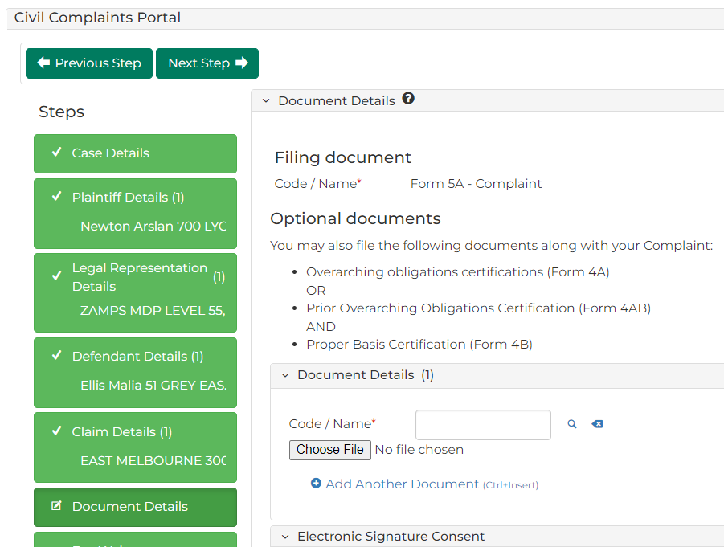
14 | Complete the required panels and fields:  PANEL: Document Details  In this field… Provide this information…  Document Details Filing document displays. Optional additional documents are listed.  Code/Name Start typing the name of the Code/Name and select relevant document from the results displayed. Click Choose File and upload the relevant PDF.  Hint:  This field can be used to upload optional documents at time of filing, such as the Overarching obligations certifications (Form 4a). If not selected at this time, the documents can be uploaded to the CMS Portal or with the registry at a later date.  Electronic Signature Consent Select the item Electronic Signature Consent.  Note: By selecting this box, I consent to my electronic signature being affixed to this document in accordance with the Electronic Transactions Act 2000 (Vic). Note: If the desired address is not displayed with the search feature, you can type each component of the address in the relevant fields.
Hint:
If you are not applying for a fee waiver for this complaint, you can skip to step 15.
15 | Click: Next Step |  |  | The Fee Waiver screen displays:  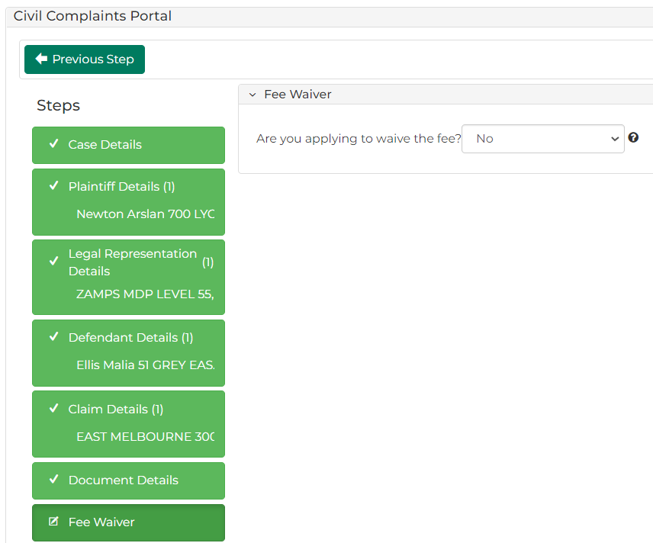
16 | From the Are you applying to waive the fee? dropdown menu, select Yes or No |  |  | If you have selected Yes, information related to the fee waiver, including an upload field for the fee waiver application, displays:
 | 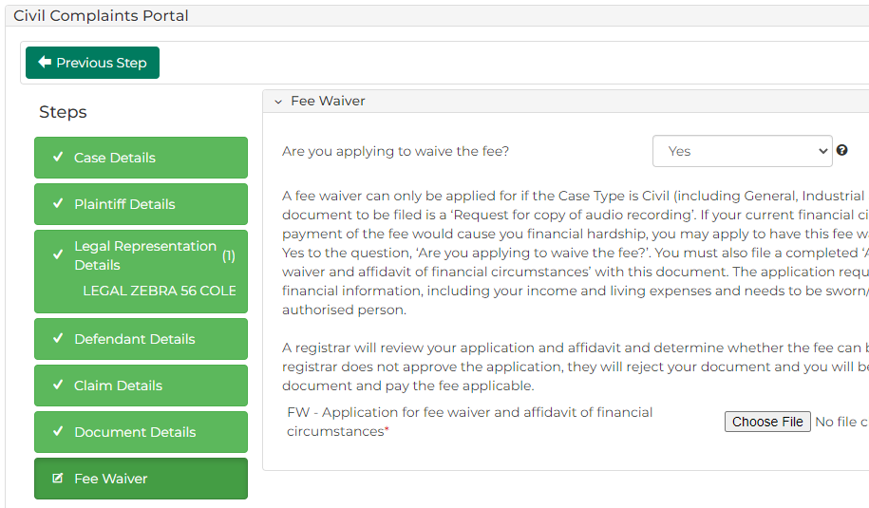
Note:
If you select Yes to fee waiver skip to Step 21.

17 | Click: Proceed |  |  | The My Account screen displays:  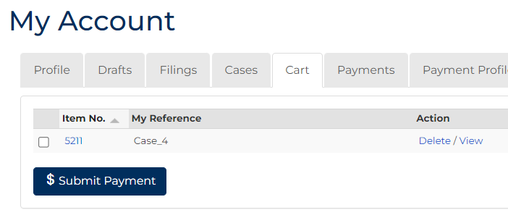
Hint:
You can return to previous sections before completing the civil complaints initiation process by clicking the green button for the desired section, or the Previous Step button.
18 | Select the item requiring payment then click: Submit Payment |  |  | The Process Payment screen displays:
 | 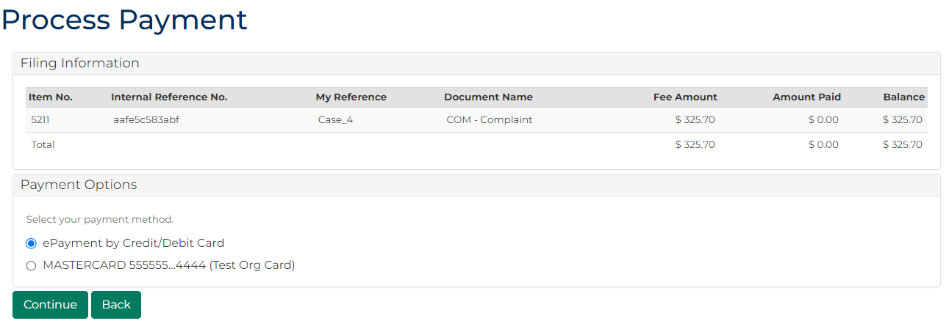
19 | From the Payment Options panel, select a payment method, then click: Continue  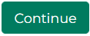 |  |  |  | Please See:  Payment options can be added and removed from the My Account screen. For more information, please see User Guide: My account
20 | What payment method was selected?  If … Then …  ePayment by Credit/Debit Card The Payment Processing screen displays: Enter payment details then select: Make Payment  A stored credit card on your account Proceed step 20.
21 | The complaint is filed. The Confirmation of Filing screen displays:  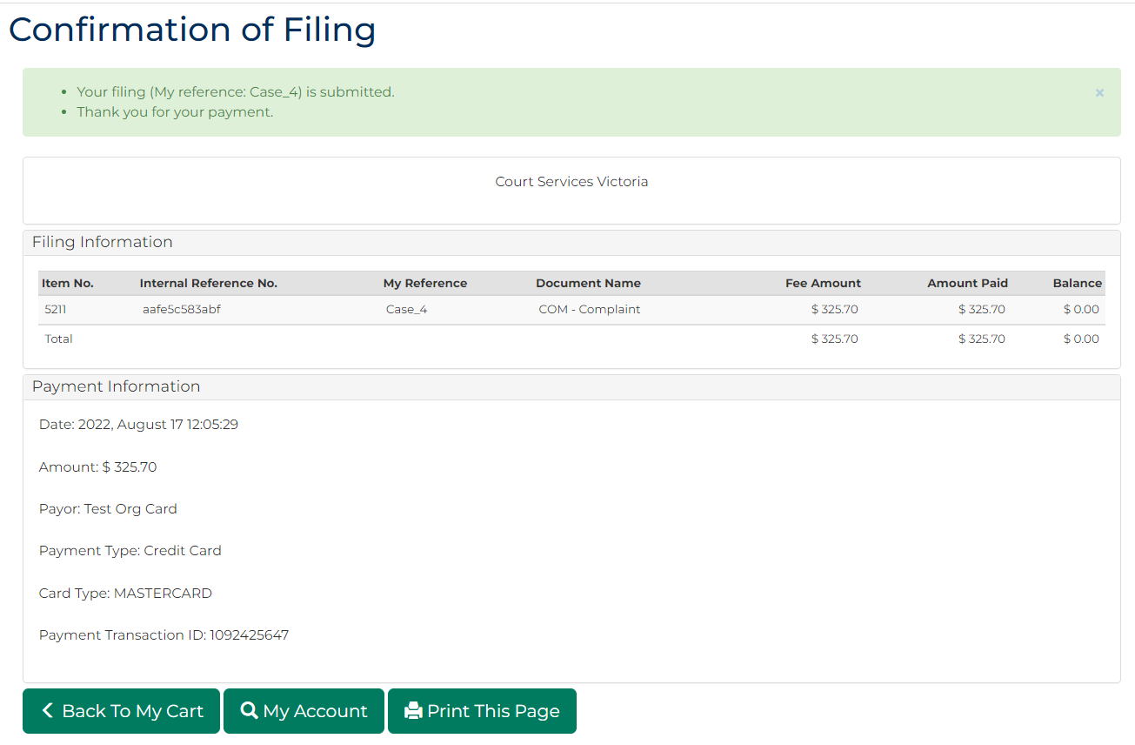
Note:
An email confirmation is sent to the email address associated to your CMS Portal account.

