Download document
This User Guide outlines how to download documents from the Portal, including:
- Documents previously filed by your organisation
- Documents filed by another party in a case managed by your organisation
Prerequisites:
Before following the steps in this User Guide, ensure:
- A document is filed on a case
- Your account has access to the case in the Portal
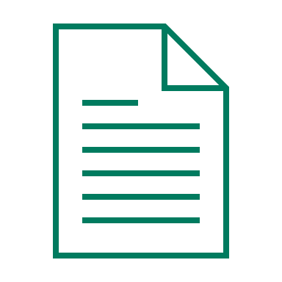 | Please see:  If the case is initiated by another user and you do not have access to the case, please see User Guide: Requesting Access to a Case

Step | Action |  |  | Result
 | Login to the CMS Portal |  |  | The CMS Portal screen displays:  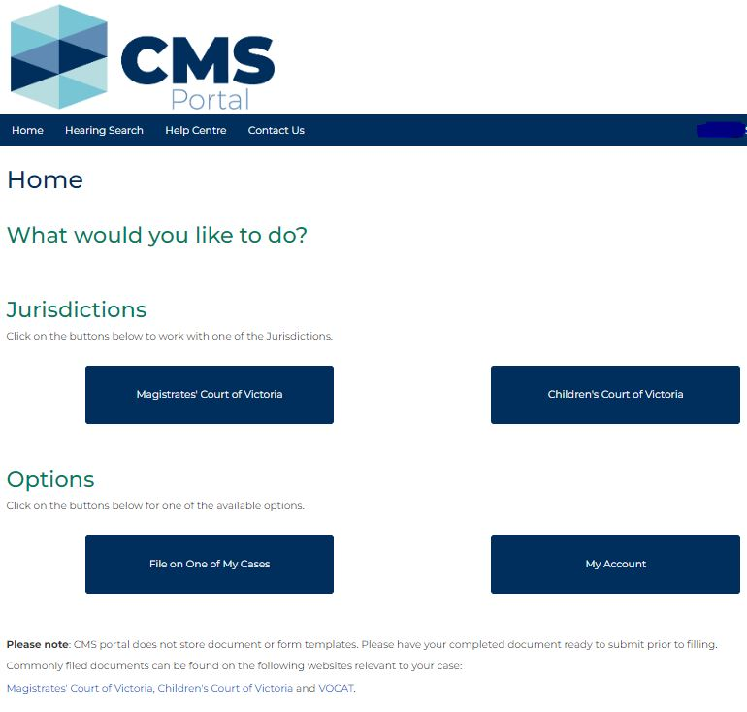
 | Click: My Account |  |  | The My Account screen displays:  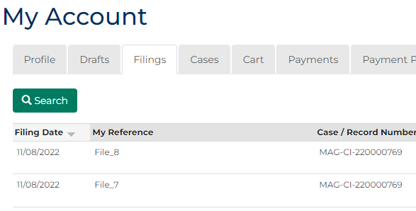
 | Click: Cases |  |  | The Search Case panel displays:
 | 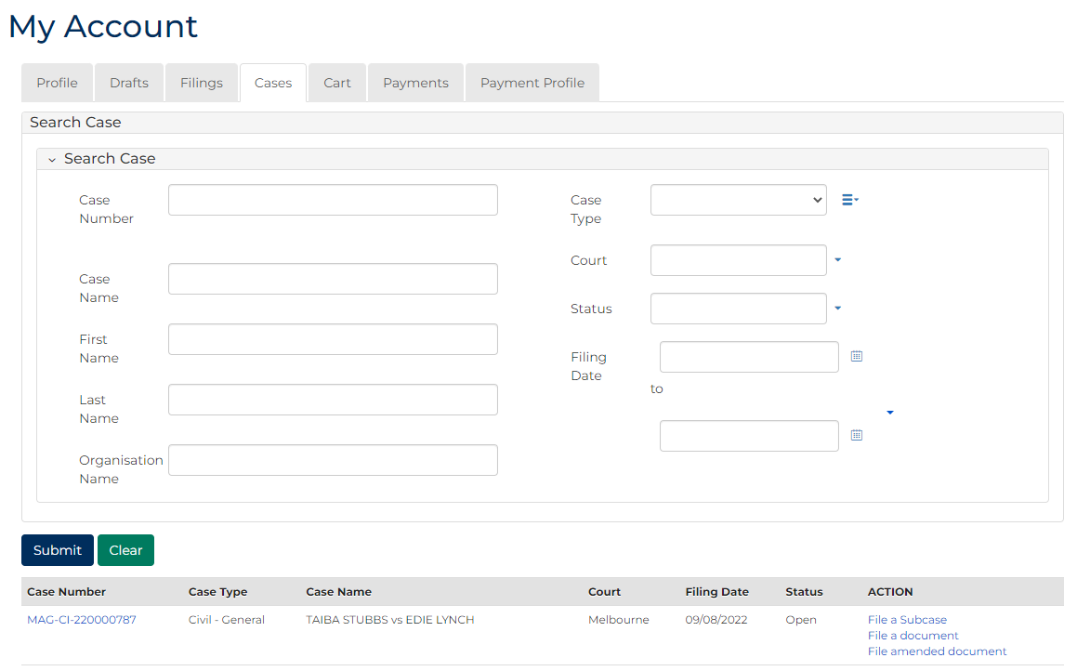
Hint:
Recently viewed cases are displayed in the panel at the bottom of the screen. If the relevant case is displayed in this panel, click the case number instead of searching for it, then go to step seven.
Enter search criteria to refine your search:
PANEL: Search Case
In this field | Enter this information
Case Number | Type the full or partial Case Number for the relevant case.
Case Name | Type the full or partial Case Name for the relevant case.
First Name | Type the First Name of a party in the case.
Last Name | Type the Last Name of a party in the case
Organisation Name | Type your Organisation Name
Case Type | Select the relevant option.
Court | Select the relevant option.
Status | Select the relevant option.
Filing Date | Select the date (or range of dates) of filing.

 | Click: Submit |  |  | The Results panel displays cases matching the search criteria:
 | 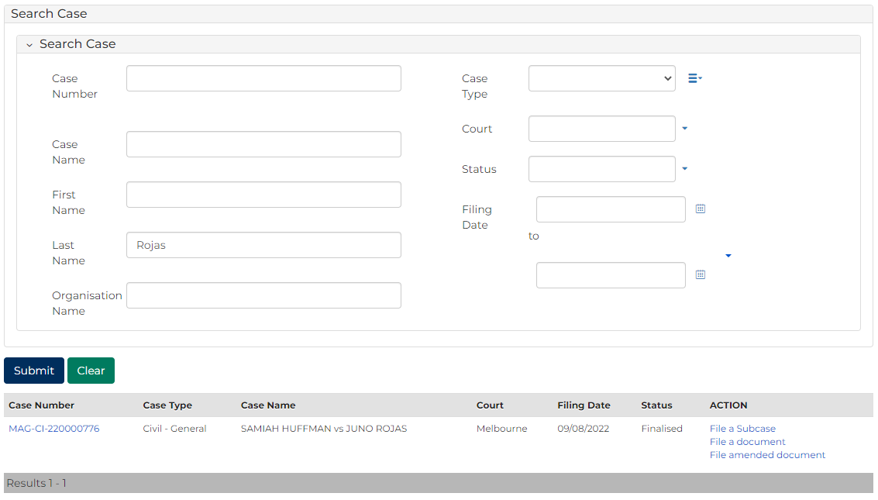
 | Is the desired case displayed in the results panel?  If … Then …  Yes Click the Case Number of the relevant case  No Return to step four and refine search |  |  | The Case Summary screen displays:  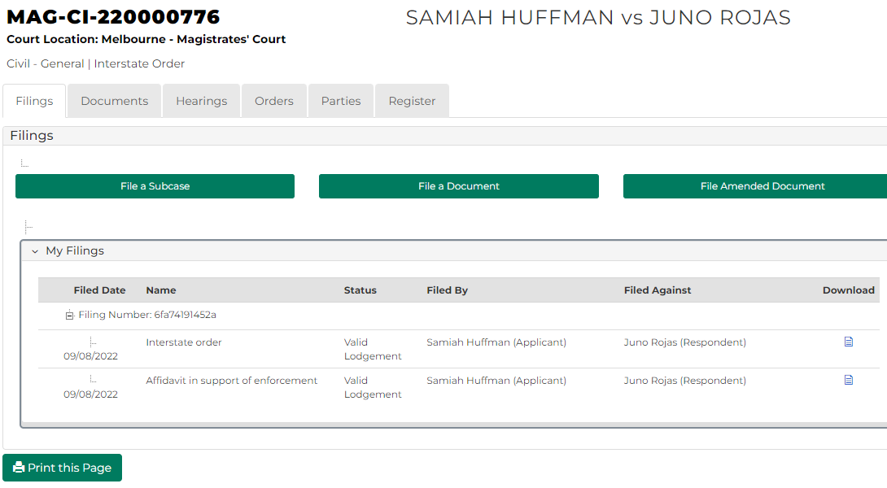
 | Click: Documents |  |  | The Case Documents panel displays:
 | 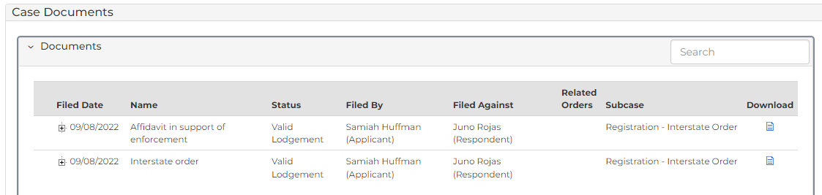
Hint:
Click the plus icon to display a list of any associated documents.
 | In the Download column, click the document icon for the relevant document |  |  | The document downloads.
Note:
The steps to locate and view the downloaded document on your computer depends on the operating system and browser.

