Add, modify and block user
Prerequisites:
To complete this User Guide, you need organisational administration profile access in the CMS Portal.

This User Guide outlines the processes required to add, modify or block users in the CMS Portal, and is divided into two parts:
Part | Page
Part 1: Add user | 2
Part 2: Modify or block user | 6

Part 1: Add user
Step | Action |  | Result
 | Log in to the CMS Portal |  | The CMS Portal home screen displays:  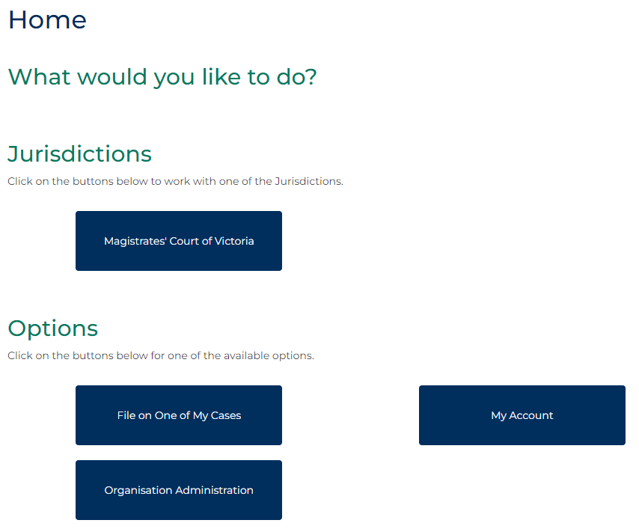
 | Click: Organisation Administration  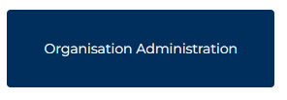 |  | The Organisation Administration screen displays:  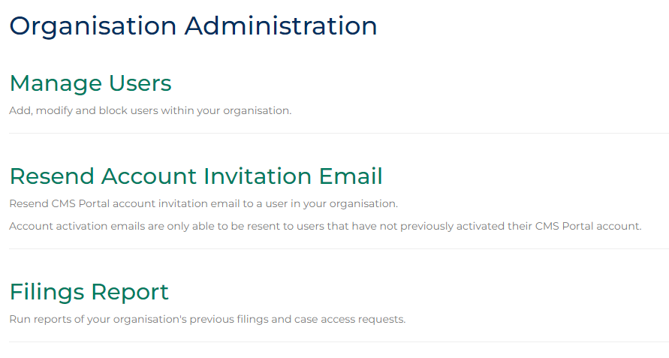
 | Click: Manage Users  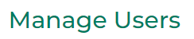 |  | The People screen displays:  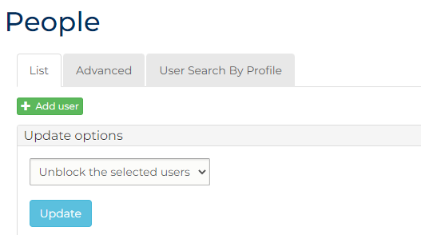
 | Click: Add User |  | The People screen displays user information fields  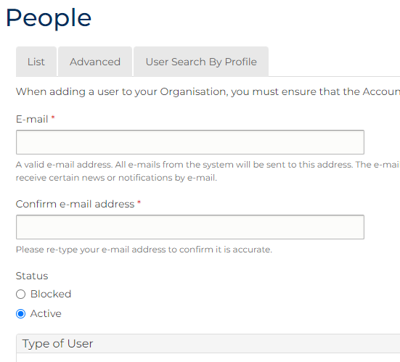
Complete the required panels and fields:
Fields marked with a red asterisk * are mandatory.
USER PANELS
In this field … | Provide this information …
E-mail | Type e-mail for relevant user.
Note:
The e-mail address entered is used in the CMS Portal to:
- Log in, and
- Receive automated notifications
Confirm e-mail address | Type e-mail address again.
Status | Select: Blocked
Important:
The account must be changed to Blocked as this prompts the user to acknowledge the CMS Portal terms and conditions upon account activation.
Continued …
5 | Continued …  USER PANELS  In this field … Provide this information …  Type of User Select the relevant option: - LLFAdmin: Organisational Administrator account - LLFUser: User account  Organisation Displays the name of your Organisation  PANEL: Personal Information  First Name Type the First Name of the user.  Surname Type the Surname of the user.  Unique ID Number Type a value as a unique identifier for the user.  Note:  This number must be provided to the user to enter on account activation.  Secondary Email Address for All Notifications Type an email address in addition to the user’s primary e-mail to receive copies of notifications.  Secondary Email Address for Rejections Type an email address in addition to the user’s primary e-mail to receive copies of rejections, in addition to the user’s e-mail address.  Mobile Number for SMS Notifications Type a mobile number to receive SMS notifications.  Phone Number Type the user’s preferred contact number.  Fax Type the user’s fax number.  Division Type the user’s division within your organisation, if applicable.  Employee Identifier Type the Employee Identifier used internally by your organisation, if applicable.
 | Click the box in the Captcha  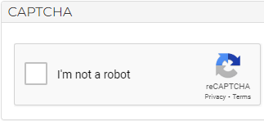 |  | A confirmation alert displays:  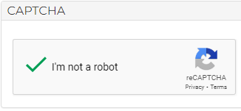
 | Click: Create new account  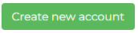 |  | A confirmation message displays:
Note:
The user is sent an email notifying them of the account creation, which contains a link the user needs to click to activate their account:
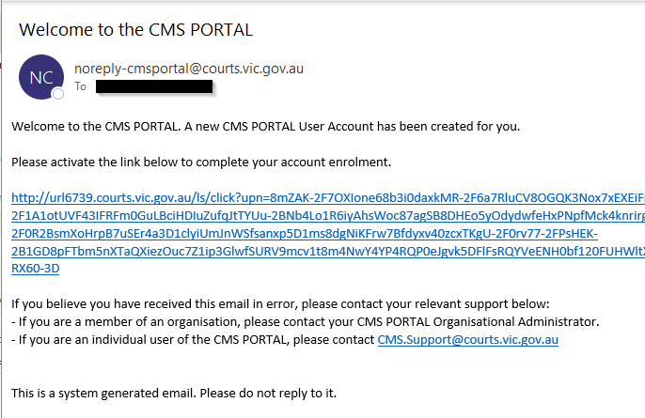
Important:
Provide the user with the Unique ID Number for their account. This must be entered by the user as part of the account activation process.

Part 2: Modify or block user
Note:
- The steps in this section of the User Guide outline the process for CMS Portal administrators to modify user accounts.
- CMS Portal users with a defined LLFUser role can modify the following fields of their own accounts:
Field
First name
Surname
Secondary Email Address for All Notifications
Secondary Email Address for Rejections
Mobile Number for SMS Notifications
Phone Number
Fax

Important:
To block user accounts from accessing the CMS Portal with your organisation, follow the steps in this section of the User Guide to change the user’s Status to Blocked
The user is sent a notification email when their account is blocked:
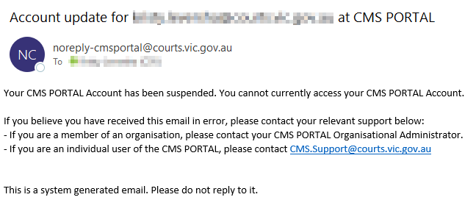

Step | Action |  | Result
 | Log in to the CMS Portal |  | The CMS Portal home screen displays:
 | Click: Organisation Administration |  | The Organisation Administration screen displays:
 | Click: Manage Users |  | The People screen with a list of users in your organisation displays:  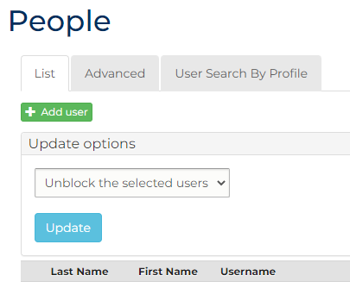
 | OPTIONAL:  To search for a specific user, click: User Search by Profile  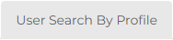 |  | The People screen, open to the User Search By Profile tab, displays:  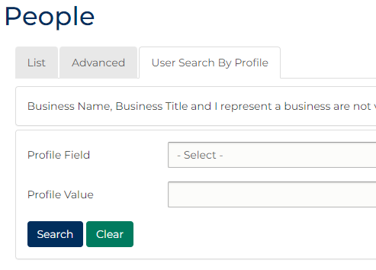  Select the relevant Profile Field from the drop-down box and input a Profile Value (e.g. a specific surname), then click: Search.  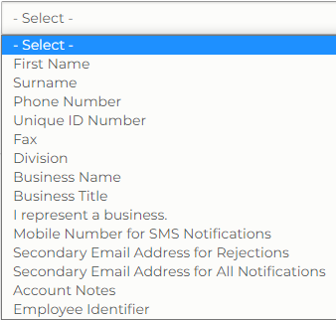
 | OPTIONAL:  To filter users by a specific field, click: Advanced  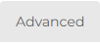 |  | The People screen, open to the Advanced tab, displays:  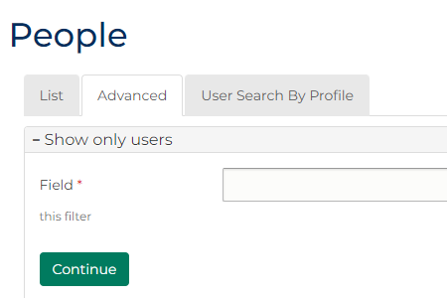  Select the relevant Field from the drop-down box, then click: Continue.  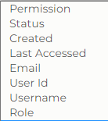  Select the relevant Operator from the drop-down box (these will differ based on the field you selected). Complete the Data field – depending on the option you selected you will either input the relevant information into a text field or select an option from a drop-down box. Click: Filter.  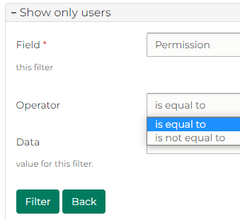
 | In the Operations column for the relevant account, click: edit  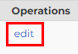 |  | The My Account screen, open to the relevant user’s account, displays:  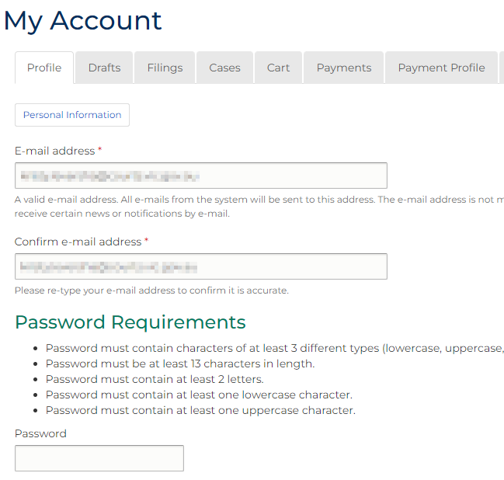
 | OPTIONAL:  To modify additional user fields, click: Personal Information  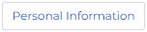 |  | The My Account screen displays additional fields:  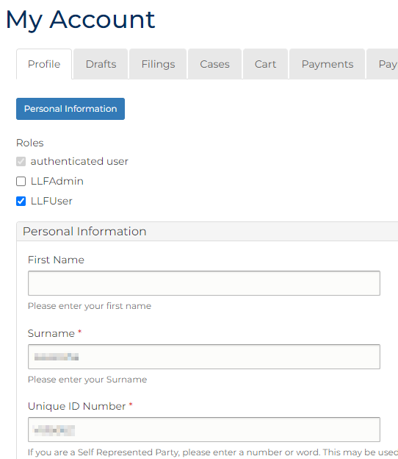
 | Modify the relevant user fields, then click: Save  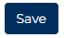 |  | A confirmation message displays:  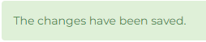
Hint:
To block a CMS Portal account, on the Profile page, change Status from Active to Blocked, then click: Save
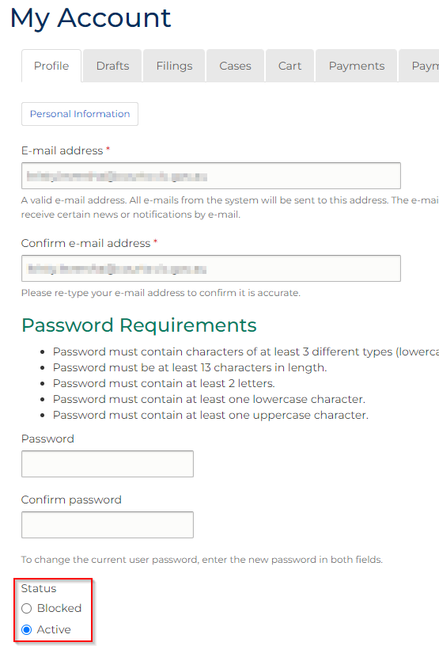
Hint:
Some changes to user accounts can be done in bulk, including:
- Changes to users blocked/unblocked status, and
- Adding or removing of roles.
To make bulk changes, from the list of users on the People screen, select the relevant users and use the menu in the Update Options panel to make the desired change:
